Department: Computer Engineering

Cover Page

Subject: CN

Semester: V

Hardware Requirement: Computer

Theory Faculty In-charge: Prof. Sandeep Kamble

Practical Faculty In-charge: Prof. Sandeep Kamble

Lab: M312B

Lab In-charge: Prof. Sneha Annapannavar
Lab Assistant:

INDEX (PRACTICAL / TUTORIAL PLAN)

Expt. No. | Experiment Title | New/ Repeated | Schedule Date
 |  |  | Batch 1 | Batch 2 |  | Batch 3 | Batch 4
1 | Study of networking historical perspective,types of network,networking devices, topologies in packet tracer and current trends in networking services. | NEW | 12-07-2018 |  | NA | NA | NA
2 | Use of basic networking commands | NEW | 12-07-2018 |  | NA | NA | NA
3 | Use wireshark to understand the operation of tcp/ip layers | NEW | 12-07-2018 |  | NA | NA | NA
4 | Write a program to find out class of given ip address and subnet mask& first and last ip address of the block | NEW | 12-07-2018 |  | NA | NA | NA
5 | Implement CRC error detection mechanism | NEW | 23-08-2018 |  | NA | NA | NA
6 | Socket programming for tcp and udp | NEW | 23-08-2018 |  | NA | NA | NA
7 | Setting up multiple ip on single NIC card  Using netstat and route command of linux to do following  1.view current routing tables  2.add and delete routes  3.to change default gateway | NEW | 23-08-2018 |  | NA | NA | NA
8 | Use of ip tables and create firewall | NEW | 27-09-2018 |  | NA | NA | NA
9 | File transfer and access using ftp | NEW | 27-09-2018 |  | NA | NA | NA
10 | Perform remote login using telnet server | NEW | 27-09-2018 |  | NA | NA | NA

Experiment No.1

Experiment Number | 1
Experiment Title | Study of networking historical perspective,types of network,networking devices, topologies in packet tracer and current trends in networking services.
Resources / Apparatus Required | Hardware:  PC | Software:
Objectives  (Skill Set / Knowledge Tested / Imparted) | To know basics about networking and networking devices.
Theory/Diagrams/ER Diagrams/Code/Conclusion/  Real-Life Application/FAQ’s | HISTORY OF COMPUTER NETWORKS:  A computer network, or data network, is a digital telecommunications network which allows nodes to share resources. In computer networks, computing devices exchange data with each other using connections (data links) between nodes. These data links are established over cable media such as wires or optic cables, or wireless media such as Wi-Fi.  Network computer devices that originate, route and terminate the data are called network nodes.^{[1]} Nodes can include hosts such as personal computers, phones, servers as well as networking hardware. Two such devices can be said to be networked together when one device is able to exchange information with the other device, whether or not they have a direct connection to each other. In most cases, application-specific communications protocols are layered (i.e. carried as payload) over other more general communications protocols. This formidable collection of information technology requires skilled network management to keep it all running reliably.  NETWORKING DEVICES:  Networking devices may include gateways, routers, network bridges, modems, wireless access points, networking cables, line drivers, switches, hubs, and repeaters; and may also include hybrid network devices such as multilayer switches, protocol converters, bridge routers, proxy servers, firewalls, networkaddress ...  Types of network devices  - Repeater  - Hub.  - Bridge  - Switch.  - Routers.  - Gateway  - Brouters  - REPEATER  A repeater operates at the physical layer. Its job is to regenerate the signal over the same network before the signal becomes too weak or corrupted so as to extend the length to which the signal can be transmitted over the same network. An important point to be noted about repeaters is that they do not amplify the signal. When the signal becomes weak, they copy the signal bit by bit and regenerate it at the original strength. It is a 2 port device.  - HUB  A hub is basically a multiport repeater. A hub connects multiple wires coming from different branches, for example, the connector in star topology which connects different stations. Hubs cannot filter data, so data packets are sent to all connected devices. In other words, collision domain of all hosts connected through Hub remains one. Also, they do not have intelligence to find out best path for data packets which leads to inefficiencies and wastage..  - BRIDGE  A bridge operates at data link layer. A bridge is a repeater, with add on functionality of filtering content by reading the MAC addresses of source and destination. It is also used for interconnecting two LANs working on the same protocol. It has a single input and single output port, thus making it a 2 port device.  - SWITCH  A switch is a multi port bridge with a buffer and a design that can boost its efficiency(large number of ports imply less traffic) and performance. Switch is data link layer device. Switch can perform error checking before forwarding data, that makes it very efficient as it does not forward packets that have errors and forward good packets selectively to correct port only. In other words, switch divides collision domain of hosts, but broadcast domain name same.  - ROUTERS  A router is a device like a switch that routes data packets based on their IP addresses. Router is mainly a Network Layer device. Routers normally connect LANs and WANs together and have a dynamically updating routing table based on which they make decisions on routing the data packets. Router divide broadcast domains of hosts connected through it.  - GATEWAY  A gateway, as the name suggests, is a passage to connect two networks together that may work upon different networking models. They basically works as the messenger agents that take data from one system, interpret it, and transfer it to another system. Gateways are also called protocol converters and can operate at any network layer. Gateways are generally more complex than switch or router.  - BROUTER  It is also known as bridging router is a device which combines features of both bridge and router. It can work either at data link layer or at network layer. Working as router, it is capable of routing packets across networks and working as bridge, it is capable of filtering local area network traffic  TOPOLOGY: Network Topology is the schematic description of a network arrangement, connecting various nodes(sender and receiver) through lines of connection.  TYPES OF TOPOLOGY:  - BUS TOPOLOGY:  Bus topology is a network type in which every computer and network device is connected to single cable. When it has exactly two endpoints, then it is called Linear Bus topology.  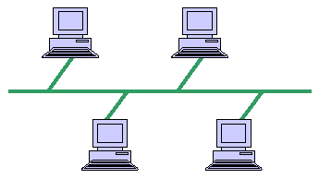  FEATURES:  - It transmits data only in one direction.  - Every device is connected to a single cable  - RING TOPOLOGY:  It is called ring topology because it forms a ring as each computer is connected to another computer, with the last one connected to the first. Exactly two neighbours for each device.  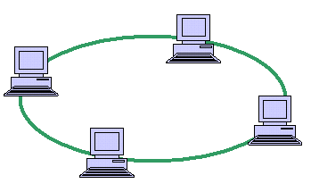  FEATURES:  - The transmission is unidirectional, but it can be made bidirectional by having 2 connections between each Network Node, it is called Dual Ring Topology.  - Data is transferred in a sequential manner that is bit by bit. Data transmitted, has to pass through each node of the network, till the destination node  - STAR TOPOLOGY:  In this type of topology all the computers are connected to a single hub through a cable. This hub is the central node and all others nodes are connected to the central node.  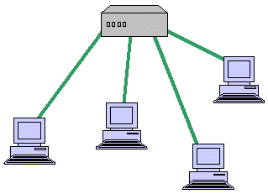  FEATURES:  - Every node has its own dedicated connection to the hub.  - Hub acts as a repeater for data flow.  - Can be used with twisted pair, Optical Fibre or coaxial cable.  - MESH TOPOLOGY:  It is a point-to-point connection to other nodes or devices. All the network nodes are connected to each other. Mesh has n(n-1)/2 physical channels to link n devices.  There are two techniques to transmit data over the Mesh topology, they are :  - Routing  - Flooding  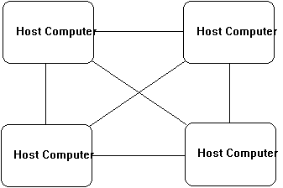  FEATURES :  - Fully connected.  - Not flexible.  - TREE Robust.  TREE TOPOLOGY:  It has a root node and all other nodes are connected to it forming a hierarchy. It is also called hierarchical topology. It should at least have three levels to the hierarchy.  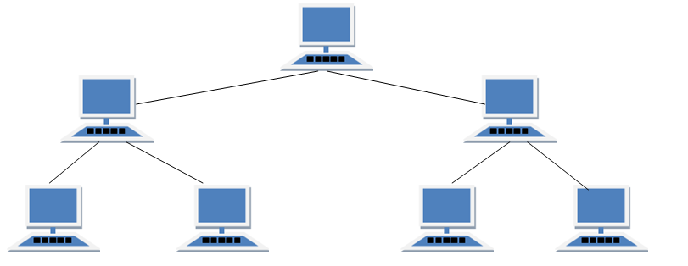  FEATURES:  - Ideal if workstations are located in groups.  - Used in Wide Area Network.  HYBRID TOPOLOGY:  It is two different types of topologies which is a mixture of two or more topologies. For example if in an office in one department ring topology is used and in another star topology is used, connecting these topologies will result in Hybrid Topology (ring topology and star topology).  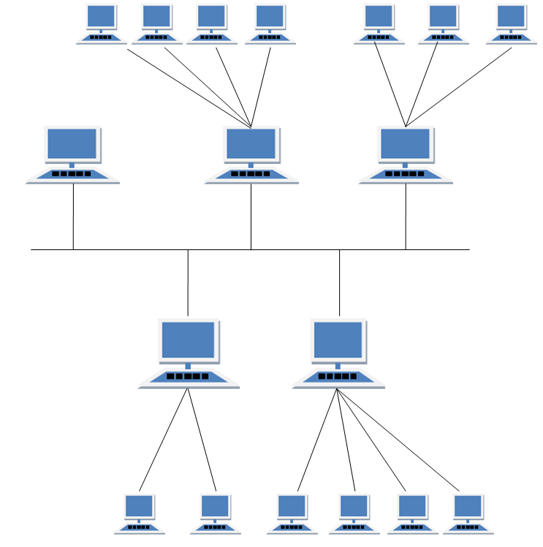  FEATURES:  - It is a combination of two or topologies  - Inherits the advantages and disadvantages of the topologies included  LAN:-  A local area network (LAN) is a group of computers and associated devices that share a common communications line or wireless link to a server. Typically, a LAN encompasses computers and peripherals connected to a server within a distinct geographic area such as an office or a commercial establishment  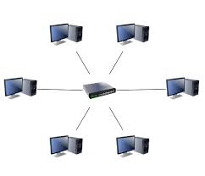  A LAN is a network of computers that are in the same general physical location, usually within a building or a campus. If the computers are far apart (such as across town or in different cities), then a Wide Area Network (WAN) is typically used.  WAN:  A wide area network (WAN) is a network that exists over a large-scale geographical area.  A WAN connects different smaller networks, including local area networks (LANs) and metro area networks (MANs). his ensures that computers and users in one location can communicate with computers and users in other locations.  WAN implementation can be done either with the help of the public transmission system or a private network. A WAN connects more than one LAN and is used for larger geographical areas. WANs are similar to a banking system, where hundreds of branches in different cities are connected with each other in order to share their official data.  A WAN works in a similar fashion to a LAN, just on a larger scale. Typically, TCP/IP is the protocol used for a WAN in combination with devices such as routers, switches, firewalls and modems.  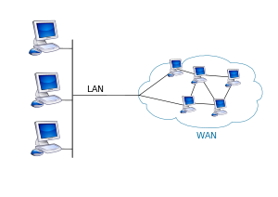  MAN:-  A metropolitan area network (MAN) is a computer network that interconnects users with computer resources in a geographic area or region larger than that covered by even a large local area network (LAN) but smaller than the area covered by a wide area network (WAN). The term MAN is applied to the interconnection of networks in a city into a single larger network which may then also offer efficient connection to a wide area network. It is also used to mean the interconnection of several local area networks in a metropolitan area through the use of point-to-point connections between them.  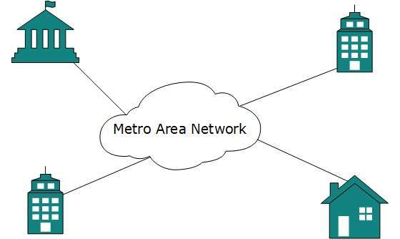
Conclusion | Thus now we know about topologies and history of networking

Experiment No.2

Experiment Number | 2
Experiment Title | Use of basic networking commands
Resources / Apparatus Required | Hardware:  PC | Software:
Objectives | Learning networking commands
Theory/Diagrams/ER Diagrams/Code/Conclusion/  Real-Life Application/FAQ’s | 1.Ping:  PING (Packet Internet Groper) command is the best way to test connectivity between two nodes. Whether it is Local Area Network (LAN) or Wide Area Network (WAN). Ping use ICMP (Internet Control Message Protocol) to communicate to other devices.  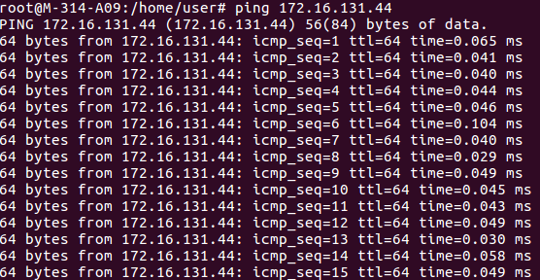  2.Nslookup:  nslookup command. nslookup (name server lookup) is a tool used to perform DNS lookups in Linux. It is used to display DNS details, such as the IP address of a particular computer, the MX records for a domain or the NS servers of a domain.  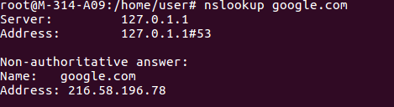  3. Traceroute:  The traceroute command is a Command Prompt command that is used to show several details about the path that a packet takes from the computer or device you're on to whatever destination you specify.  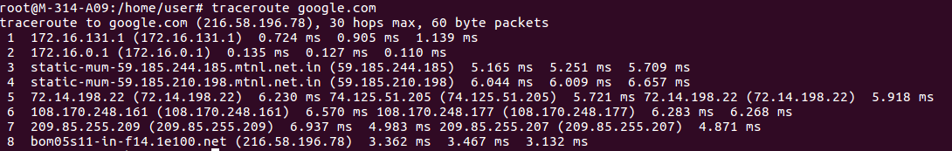  4. Arp:  Arp manipulates or displays the kernel's IPv4 network neigbour cache. It can add entries to the table, delete one, or display the current content. ARP stands for Address Resolution Protocol, which is used to find the address of a network neighbor for a given IPv4 address.  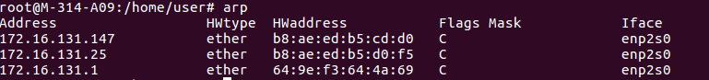  5. Rarp:  The Reverse Address Resolution Protocol (RARP) is an obsolete computer networking protocol used by a client computer to request its Internet Protocol (IPv4) address from a computer network, when all it has available is its link layer or hardware address, such as a MAC address.  6. Ifconfig:  Running ifconfig with no options will display the configuration of all active interfaces. Displays the configuration of all interfaces, both active and inactive.  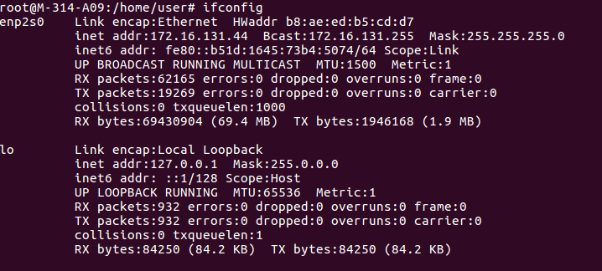  7. Netstat:  Netstat (network statistics) is a command-line tool that displays network connections (both incoming and outgoing), routing tables, and a number of network interface statistics.  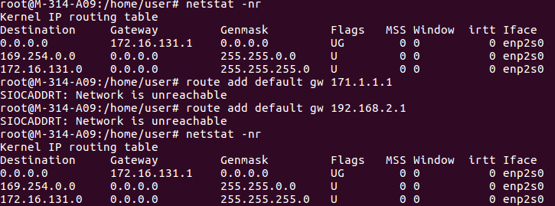
Conclusion | Thus we studies networking commands

Experiment No.3

Experiment Number | 3
Experiment Title | User wireshark to understand the operation of tcp/ip layers
Resources / Apparatus Required | Hardware:  PC | Software:
Objectives  (Skill Set / Knowledge Tested / Imparted) | To trace packets using wireshark
Theory/Diagrams/ER Diagrams/Code/Conclusion/  Real-Life Application/FAQ’s | Q1. What is TCPDUMP?  Ans. TCPDUMP is a common packet analyzer that runs under the command line. It allows the user to display TCP/IP and other packets being transmitted or received over a network to which the computer is attached. Distributed under the BSD license, tcpdump is free software. Tcpdump works on most Unix-like operating systems: Linux, Solaris. The port of tcpdump for Windows is called WinDump; it uses WinPcap, the Windows port of libpcap.  Tcpdump prints the contents of network packets. It can read packets from a network interface card or from a previously created saved packet file. tcpdump can write packets to standard output or a file.  It is also possible to use tcpdump for the specific purpose of intercepting and displaying the communications of another user or computer. A user with the necessary privileges on a system acting as a router or gateway through which unencrypted traffic such as Telnet or HTTP passes can use tcpdump to view login IDs, passwords, the URLs and content of websites being viewed, or any other unencrypted information.  TCPDUMP Installation Process:  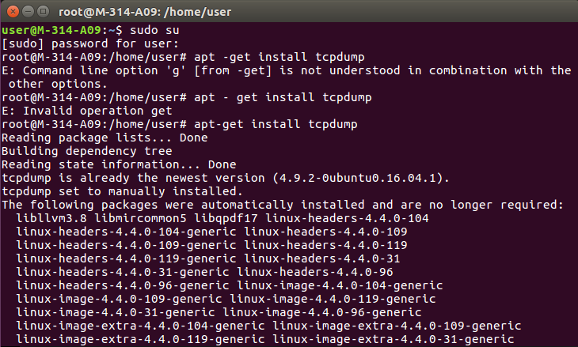  Q2. What is WIRESHARK?  Ans. Wireshark is a free and open source packet analyzer. It is used for network troubleshooting, analysis, software and communications protocol development, and education. Originally named Ethereal, the project was renamed Wireshark in May 2006 due to trademark issues. Wireshark is cross-platform, using the Qt widget toolkit in current releases to implement its user interface, and using pcap to capture packets; it runs on Linux, macOS, BSD, Solaris, some other Unix-like operating systems, and Microsoft Windows.  Wireshark is very similar to tcpdump, but has a graphical front-end, plus some integrated sorting and filtering options. Wireshark lets the user put network interface controllers into promiscuous mode (if supported by the network interface controller), so they can see all the traffic visible on that interface including unicast traffic not sent to that network interface controller's MAC address.  WIRESHARK Installation Process:  1.  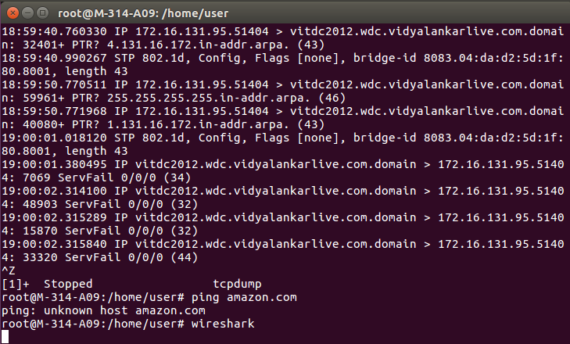  2.  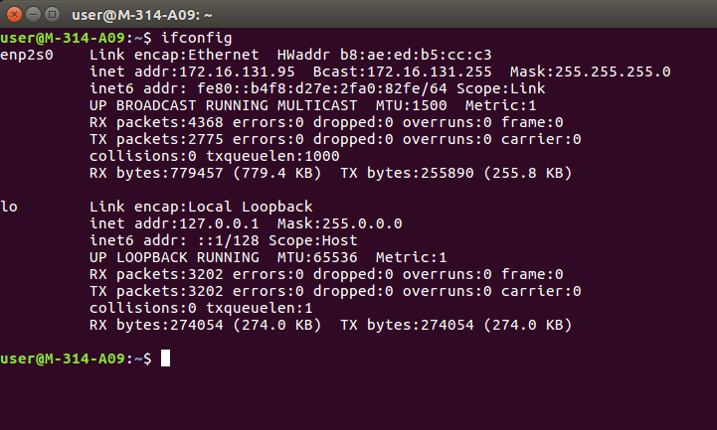  Procedure:  Step1: Open Wireshark and select the interface name.  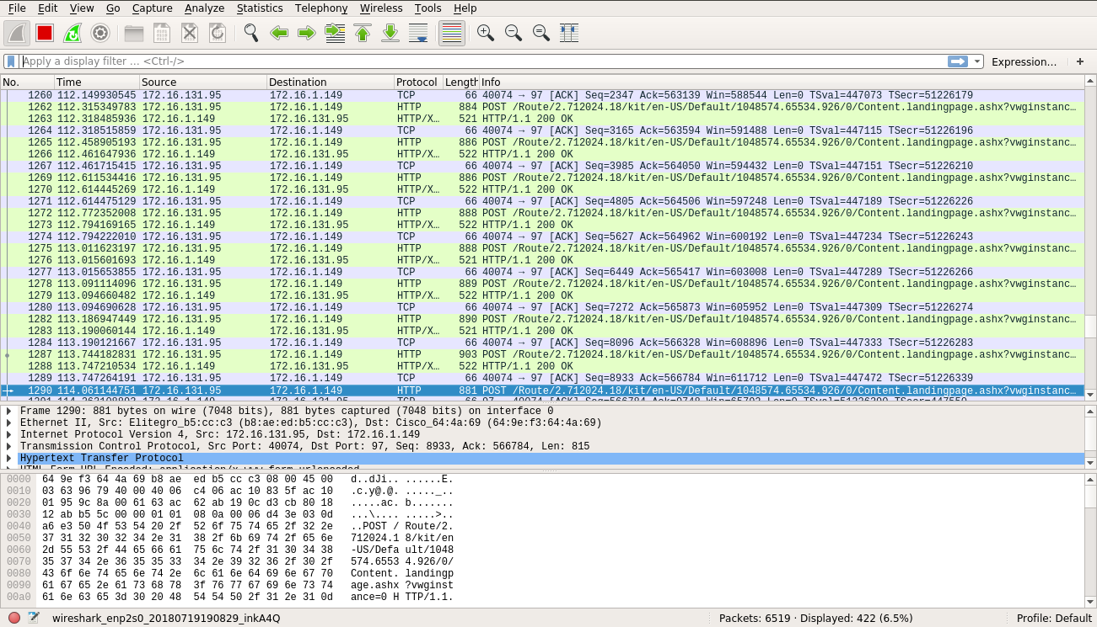  Step2: Select filter.  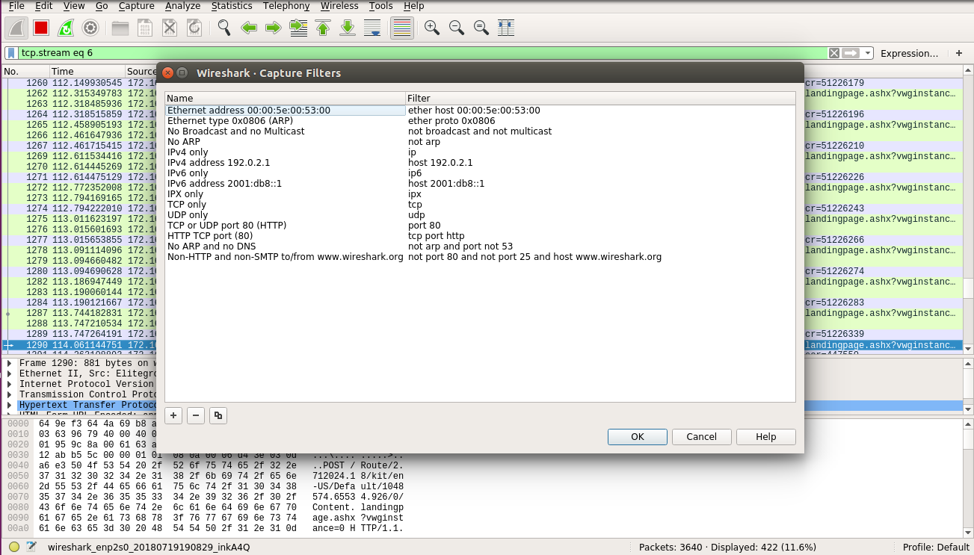  Step3: Open any website with ‘http’ filter in background and enter ‘http’ in filter option.  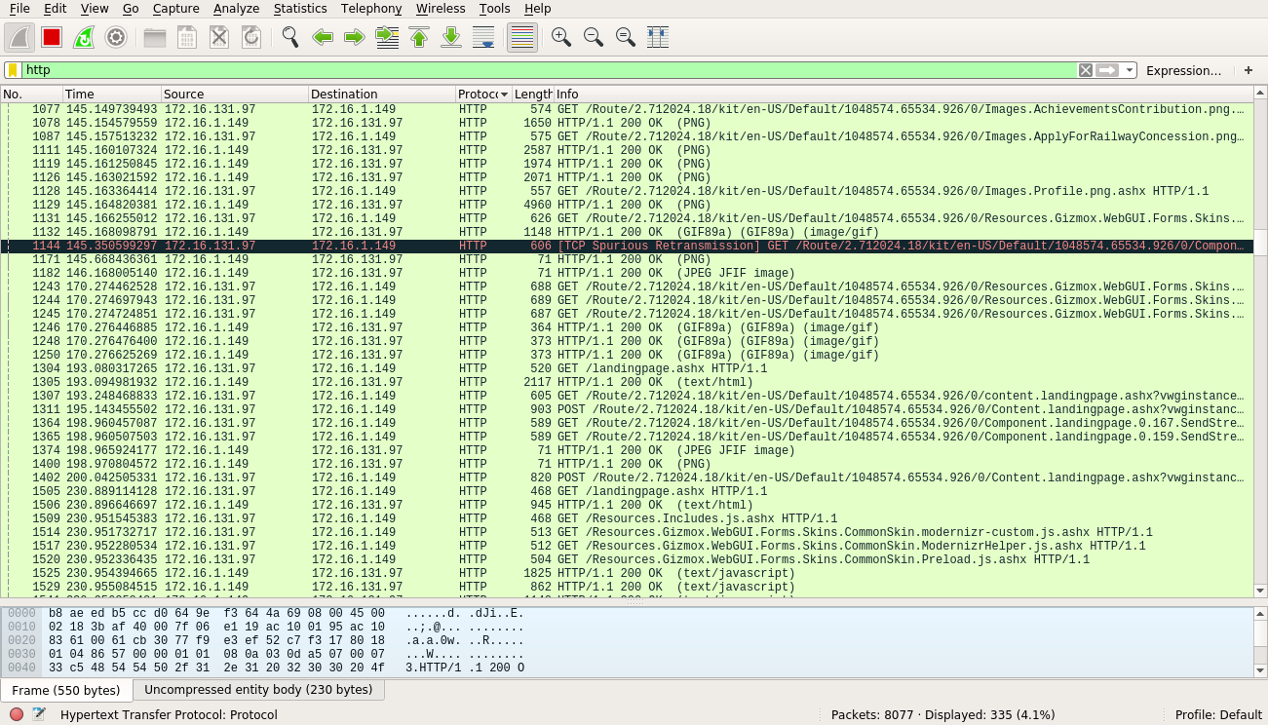  Select any POST protocol from Info tab whose IP is same as the selected website.  Step4: Search for password by typing a few letters.  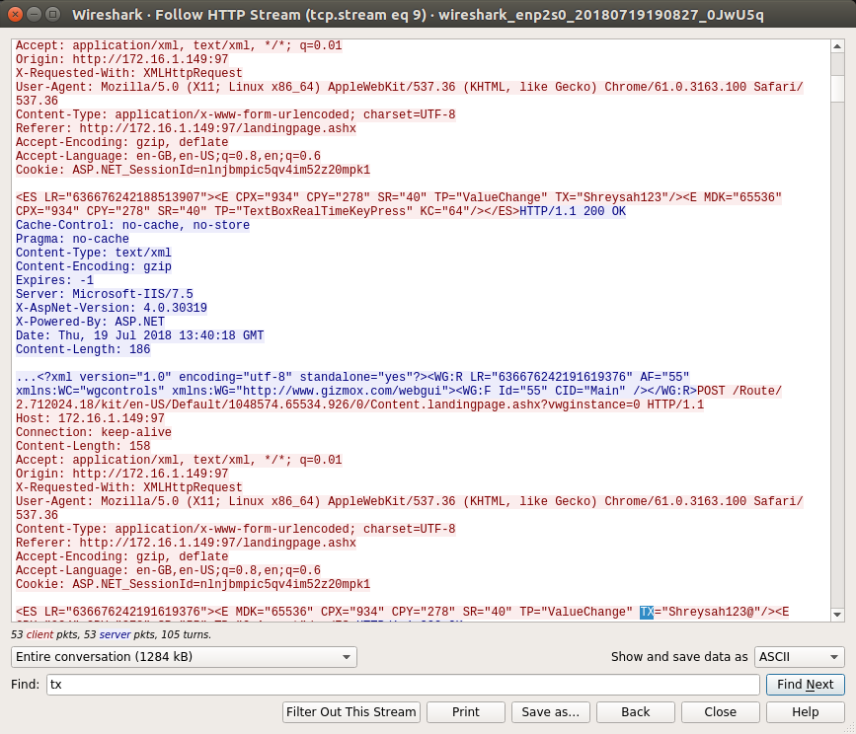  Q3. How to set promiscuous mode and non-promiscuous mode in Wireshark?  Ans. In a network, promiscuous mode allows a network device to intercept and read each network packet that arrives in its entirety. This mode of operation is sometimes given to a network snoop server that captures and saves all packets for analysis.  Promiscuous mode is the opposite of non-promiscuous mode. When a data packet is transmitter in non-promiscuous mode, all the LAN devices “listen to” theirs. If it isn’t, the data packet is passed onto the next LAN device until the device with the correct network address is reached. That device then receives and reads the data.  To set promiscuous mode:  1. Click on Capture.  2. Click on options. A pop-up dialog box appears.  3. Click on Capture options. A pop-up dialog box appears.  4. Select the interface name.  5. Check the box with the label “Capture all in Promiscuous mode”.  Q4. Difference between TCPDUMP and WIRESHARK.
  TCPDUMP | WIRESHARK
  This is a program provided by the operating system , which read packets over network interface. | This is a GUI based tool , which accepts the input. The input is same as created by the tcpdump.
  The output can be displayed on the terminal. | The output can be displayed on GUI based display.
  The file is a pcap file. This also accepts many filters for specific capture of data. | It also uses libpacp lib , so that it can also capture the packets, directly from interface.
  tcpdump - limited protocol decoding but available on most *NIX platforms | wireshark - powerfull sniffer which can decode lots of protocols, lots of filters.
Conclusion | Thus, packets of erp can be traced using wireshark

Experiment No.4

Experiment Number | 4
Experiment Title | Write a program to find out class of given ip address and subnet mask& first and last ip address of the block
Resources / Apparatus Required | Hardware:  PC | Software:  Java
Objectives  (Skill Set / Knowledge Tested / Imparted) | To find class of given ip and subnet mask
Theory/Diagrams/ER Diagrams/Code/Conclusion/  Real-Life Application/FAQ’s | import java.util.Scanner;  public class Subnet{  public static void main(String args[]){  Scanner sc = new Scanner(System.in);  System.out.print("Enter the ip address: ");  String ip = sc.nextLine();  String split_ip[] = ip.split("\\."); //SPlit the string after every .  String split_bip[] = new String[4]; //split binary ip  String bip = "";  for(int i=0;i<4;i++){  split_bip[i] = appendZeros(Integer.toBinaryString(Integer.parseInt(split_ip[i])));  }  System.out.println("IP in binary is "+bip);  System.out.print("Enter the number of addresses: ");  int n = sc.nextInt();  //Calculation of mask  int bits = (int)Math.ceil(Math.log(n)/Math.log(2));  System.out.println("Number of bits required for address = "+bits);  int mask = 32-bits;  System.out.println("The subnet mask is = "+mask);  //Calculation of first address and last address  int fbip[] = new int[32];  for(int i=0; i<32;i++) fbip[i] = (int)bip.charAt(i)-48;  for(int i=31;i>31-bits;i--)//Get first address by ANDing last n bits with 0  fbip[i] &= 0;  String fip[] = {"","","",""};  for(int i=0;i<32;i++)  fip[i/8] = new String(fip[i/8]+fbip[i]);  System.out.print("First address is = ");  for(int i=0;i<4;i++){  System.out.print(Integer.parseInt(fip[i],2));  if(i!=3) System.out.print(".");  }  System.out.println();  int lbip[] = new int[32];  for(int i=0; i<32;i++) lbip[i] = (int)bip.charAt(i)-48; //convert cahracter 0,1 to integer 0,1  for(int i=31;i>31-bits;i--)//Get last address by ORing last n bits with 1  lbip[i] |= 1;  String lip[] = {"","","",""};  for(int i=0;i<32;i++)  lip[i/8] = new String(lip[i/8]+lbip[i]);  System.out.print("Last address is = ");  for(int i=0;i<4;i++){  System.out.print(Integer.parseInt(lip[i],2));  if(i!=3) System.out.print(".");  }  System.out.println();  }  static String appendZeros(String s){  String temp = new String("00000000");  return temp.substring(s.length())+ s;  }  }  Input:  ip: 100.110.150.10  No of addresses: 7  Output::  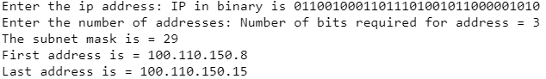
Conclusion | Thus, we successfully found the ip and subnet mask of given class

Experiment No.5

Experiment Number | 5
Experiment Title | Implement CRC error detection mechanism
Resources / Apparatus Required | Hardware:  PC | Software:
Objectives  (Skill Set / Knowledge Tested / Imparted) | To learn CRC error detection method.
Theory/Diagrams/ER Diagrams/Code/Conclusion/  Real-Life Application/FAQ’s | import java.io.*;  class crc_gen  {  public static void main(String args[]) throws IOException  {  BufferedReader br=new BufferedReader(new InputStreamReader(System.in));  int[] data;  int[] div;  int[] divisor;  int[] rem;  int[] crc;  int data_bits, divisor_bits, tot_length;  System.out.println("Enter number of data bits : ");  data_bits=Integer.parseInt(br.readLine());  data=new int[data_bits];  System.out.println("Enter data bits : ");  for(int i=0; i<data_bits; i++)  data[i]=Integer.parseInt(br.readLine());  System.out.println("Enter number of bits in divisor : ");  divisor_bits=Integer.parseInt(br.readLine());  divisor=new int[divisor_bits];  System.out.println("Enter Divisor bits : ");  for(int i=0; i<divisor_bits; i++)  divisor[i]=Integer.parseInt(br.readLine());  /* System.out.print("Data bits are : ");  for(int i=0; i< data_bits; i++)  System.out.print(data[i]);  System.out.println();  System.out.print("divisor bits are : ");  for(int i=0; i< divisor_bits; i++)  System.out.print(divisor[i]);  System.out.println();  */ tot_length=data_bits+divisor_bits-1;  div=new int[tot_length];  rem=new int[tot_length];  crc=new int[tot_length];  /*------------------ CRC GENERATION-----------------------*/  for(int i=0;i<data.length;i++)  div[i]=data[i];  System.out.print("Dividend (after appending 0's) are : ");  for(int i=0; i< div.length; i++)  System.out.print(div[i]);  System.out.println();  for(int j=0; j<div.length; j++){  rem[j] = div[j];  }  rem=divide(div, divisor, rem);  for(int i=0;i<div.length;i++) //append dividend and ramainder  {  crc[i]=(div[i]^rem[i]);  }  System.out.println();  System.out.println("CRC code : ");  for(int i=0;i<crc.length;i++)  System.out.print(crc[i]);  /*-------------------ERROR DETECTION---------------------*/  System.out.println();  System.out.println("Enter CRC code of "+tot_length+" bits : ");  for(int i=0; i<crc.length; i++)  crc[i]=Integer.parseInt(br.readLine());  /* System.out.print("crc bits are : ");  for(int i=0; i< crc.length; i++)  System.out.print(crc[i]);  System.out.println();  */  for(int j=0; j<crc.length; j++){  rem[j] = crc[j];  }  rem=divide(crc, divisor, rem);  for(int i=0; i< rem.length; i++)  {  if(rem[i]!=0)  {  System.out.println("Error");  break;  }  if(i==rem.length-1)  System.out.println("No Error");  }  System.out.println("THANK YOU.... :)");  }  static int[] divide(int div[],int divisor[], int rem[])  {  int cur=0;  while(true)  {  for(int i=0;i<divisor.length;i++)  rem[cur+i]=(rem[cur+i]^divisor[i]);  while(rem[cur]==0 && cur!=rem.length-1)  cur++;  if((rem.length-cur)<divisor.length)  break;  }  return rem;  }  }  OUTPUT :  Enter number of data bits :  7  Enter data bits :  1  0  1  1  0  0  1  Enter number of bits in divisor :  3  Enter Divisor bits :  1  0  1  Data bits are : 1011001  divisor bits are : 101  Dividend (after appending 0's) are : 101100100  CRC code :  101100111  Enter CRC code of 9 bits :  1  0  1  1  0  0  1  0  1  crc bits are : 101100101  Error  THANK YOU.... :)  Press any key to continue...
Conclusion | Thus, we studies CRC error detection method.

Experiment No.6
Experiment Number | 6
Experiment Title | Socket programming for tcp and udp
Resources / Apparatus Required | Hardware:  PC | Software:
Objectives  (Skill Set / Knowledge Tested / Imparted) | To learn socket programming.
Theory/Diagrams/ER Diagrams/Code/Conclusion/  Real-Life Application/FAQ’s | getsockopt and setsockopt Functions  These two functions apply only to sockets.  sockfd must refer to an open socket descriptor. level specifies the code in the system that interprets the option: the general socket code or some protocol-specific code (e.g., IPv4, IPv6, TCP, or SCTP). optval is a pointer to a variable from which the new value of the option is fetched by setsockopt, or into which the current value of the option is stored by getsockopt. The size of this variable is specified by the final argument, as a value for setsockopt and as a value-result for getsockopt.  Pseudo code  START  Create socket using socket function  Get the TCP maximum segment size using getsockopt function  Print the TCP maximum segment size  Set the socket sendbuffer size using setsockopt function  Get the socket sendbuffer size using getsockopt function  Print the socket sendbuffer size  END  PROGRAM  #include<stdio.h>  #include<sys/types.h>  #include<sys/socket.h>  #include<string.h>  #include<netinet/in.h>  #include<netinet/tcp.h>  main()  {  int sockfd,maxseg,sendbuff,optlen;  sockfd=socket(AF_INET,SOCK_STREAM,0);  optlen=sizeof(maxseg);  if(getsockopt(sockfd,IPPROTO_TCP,TCP_MAXSEG,(char *)&maxseg,&optlen)<0)  printf("Max seg error"); else printf("TCP max seg=%d\n",maxseg); sendbuff=2500;  if(setsockopt(sockfd,SOL_SOCKET,SO_SNDBUF,(char*)&sendbuff,sizeof(sendbuff))<0)  printf("set error"); optlen=sizeof(sendbuff);  getsockopt(sockfd,SOL_SOCKET,SO_SNDBUF,(char *)&sendbuff,&optlen);  printf("send buff size=%d\n",sendbuff);  }  OUTPUT  TCP max seg=512  Send buff size=5000
  #include <sys/socket.h>
  int getsockopt(int sockfd, int level, int optname, void *optval, socklen_t *optlen);
  int setsockopt(int sockfd, int level, int optname, const void *optval socklen_t optlen);
  Both return: 0 if OK,–1 on error

Experiment No.7

Experiment Number | 7
Experiment Title | Setting up multiple ip on single NIC card  Using netstat and route command of linux to do following  1.view current routing tables  2.add and delete routes  3.to change default gateway
Resources / Apparatus Required | Hardware:  PC | Software:
Objectives  (Skill Set / Knowledge Tested / Imparted) | To learn how to set up multiple ip on single NIC card
Theory/Diagrams/ER Diagrams/Code/Conclusion/  Real-Life Application/FAQ’s | Explanation/ Stepwise-Procedure/ Algorithm:  1.Check the no. of existing connections on your LAN:  Syntax: ifconfig  First go to the /etc/sysconfig/network-scripts/ folder and then  type “vi ifconfig”.  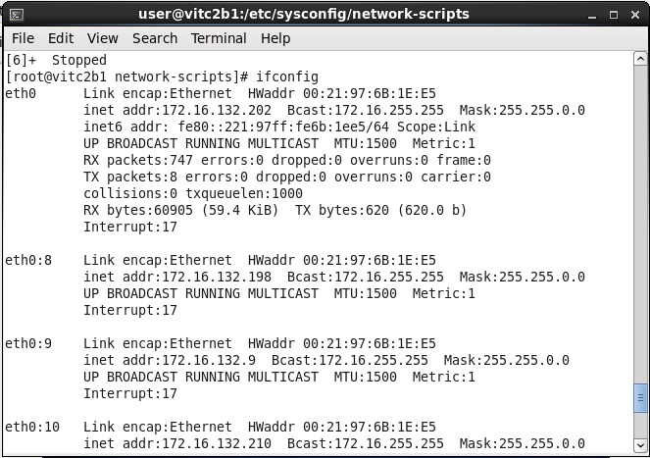  2. Create Different connections on the same LAN:  To create different connections we use “cp” command.  It copies the configuration of an existing connection to a new connection.  Syntax: cp ifcfg-<interface name> ifcfg-eth0:<interface name>  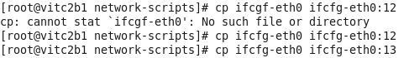  3. Configure the new connections which were created:  To configure them use “vi ifcfg-<interface name>”  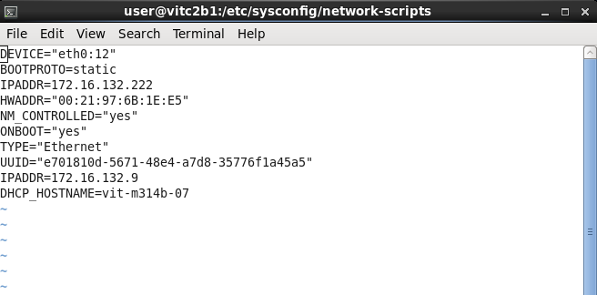  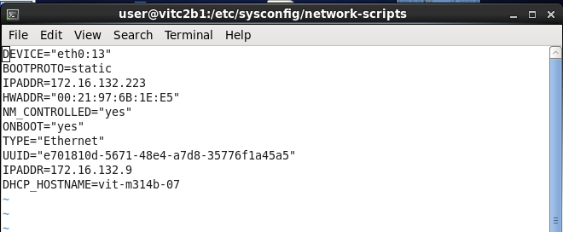  If BOOTPROTO=DHCP then make it static.  And assign a new IP Address to the connection and save your new configuration.  4. Restart your Networking Service:  To restart your networking service you can execute any of the following two commands:  - $ sudo service networking restart  - $ sudo /etc/init.d/networking restart  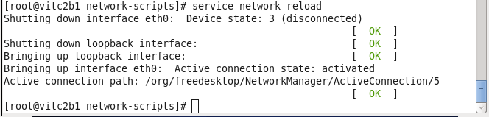  5. Check whether your new connections were added to the LAN:  You can check the new connections by using the command “ifconfig”.  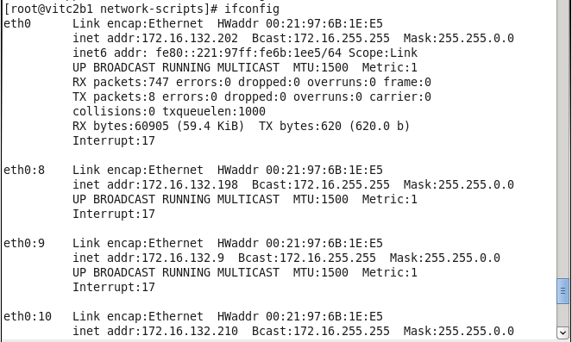  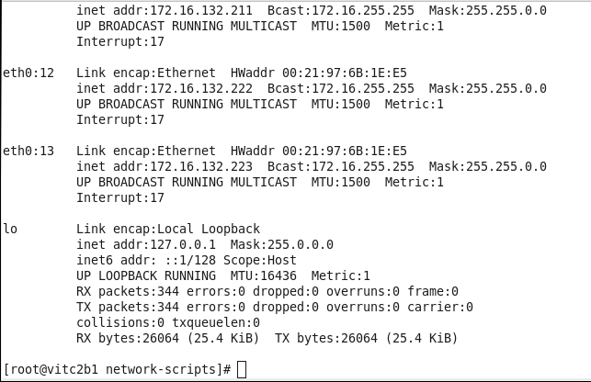
Conclusion | Thus multiple ip can be set up on single NIC card

Experiment No.8

Experiment Number | 8
Experiment Title | Use of ip tables and create firewall
Resources / Apparatus Required | Hardware:  PC | Software:
Objectives  (Skill Set / Knowledge Tested / Imparted) | To learn how firewall and iptables works.
Theory/Diagrams/ER Diagrams/Code/Conclusion/  Real-Life Application/FAQ’s | Theory and Output :  IPtables are the tables provided by the Linux kernel firewall (implemented as different Netfilter modules) and the chains and rules it stores. Different kernel modules and programs are currently used for different protocols; iptables applies to IPv4, ip6tables to IPv6, arptables to ARP, and iptables to Ethernet frames.  iptables requires elevated privileges to operate and must be executed by user root, otherwise it fails to function. On most Linux systems, iptables is installed as /usr/sbin/iptables and documented in its man pages which can be opened using man iptables when installed. It may also be found in /sbin/iptables, but since iptables is more like a service rather than an "essential binary", the preferred location remains /usr/sbin.  1. To drop all traffic:  - sudo iptables -P INPUT DROP  - sudo iptables -P OUTPUT DROP  - sudo iptables -P FORWARD DROP  - sudo iptables -L -v –n  2. Only Block Incoming Traffic  To drop all incoming / forwarded packets, but allow outgoing traffic,  - sudo iptables -P INPUT DROP  - sudo iptables -P FORWARD DROP  - sudo iptables -P OUTPUT ACCEPT  - sudo iptables -A INPUT -m state --state NEW,ESTABLISHED -j ACCEPT  - sudo iptables -L -v –n  3.Block outgoing ip address host –t a hostname  sudo iptables -A OUTPUT -d outgoing ipaddress -j DROP  4.Block or Allow ICMP ping request  sudo iptables -A INPUT -p icmp --icmp-type echo-request -j DROP/ACCEPT
Conclusion | Hence firewall are created using ip tables in linux

Experiment No.9

Experiment Number | 9
Experiment Title | File transfer and access using ftp
Resources / Apparatus Required | Hardware:  PC | Software:
Objectives  (Skill Set / Knowledge Tested / Imparted) | To transfer files using ftp
Theory/Diagrams/ER Diagrams/Code/Conclusion/  Real-Life Application/FAQ’s | Step 1: Installing FTP Server  1. Installing vsftpd server is straight forward, just run the following command in the terminal.  # yum install vsftpd  2. After the installation completes, the service will be disabled at first, so we need to start it manually for the time being and enable it to start automatically from the next system boot as well:  # systemctl start vsftpd  # systemctl enable vsftpd  3. Next, in order to allow access to FTP services from external systems, we have to open port 21, where the FTP daemons are listening as follow  # firewall-cmd --zone=public --permanent --add-port=21/tcp  # firewall-cmd --zone=public --permanent --add-service=ftp  # firewall-cmd --reload  Step 2: Configuring FTP Server  4. Now we will move over to perform a few configurations to setup and secure our FTP server, let us start by making a backup of the original config file /etc/vsftpd/vsftpd.conf:  #cp/etc/vsftpd/vsftpd.conf/etc/vsftpd/vsftpd.conf.orig  5. Now configure FTP to allow/deny FTP access to users based on the user list file /etc/vsftpd.userlist.  userlist_enable=YES # vsftpd will load a list of usernames, from the filename given by userlist_file  userlist_file=/etc/vsftpd.userlist # stores usernames.  userlist_deny=NO  6. Now add these two following options to restrict FTP users to their Home directories.  chroot_local_user=YES  allow_writeable_chroot=YES  chroot_local_user=YES means local users will be placed in a chroot jail, their home directory after login by default settings.  And also by default, vsftpd does not allow the chroot jail directory to be writable for security reasons, however, we can use the option allow_writeable_chroot=YES to override this setting.  3.Securing FTP Server with SELinux  we will use semanage command to set SELinux rule to allow FTP to read/write user’s home directory.  # semanage boolean -m ftpd_full_access --on  Restart vsftpd  # systemctl restart vsftpd  Step 4: Testing FTP Server  8. Now we will test FTP server by creating a FTP user with useradd command.  # useradd -m -c “Ravi Saive, CEO” -s /bin/bash ravi  # passwd ravi  Afterwards, we have to add the user ravi to the file /etc/vsftpd.userlist using the echo command as follows:  # echo "ravi" | tee -a /etc/vsftpd.userlist  # cat /etc/vsftpd.userlist  9. Now do a check if a user listed in the file /etc/vsftpd.userlist, is actually placed in his/her home directory after login:  # ftp 192.168.56.10  Connected to 192.168.56.10 (192.168.56.10).  220 Welcome to TecMint.com FTP service.  Name (192.168.56.10:root) : ravi  331 Please specify the password.  Password:  230 Login successful.  Remote system type is UNIX.  Using binary mode to transfer files.  ftp> ls  Output::  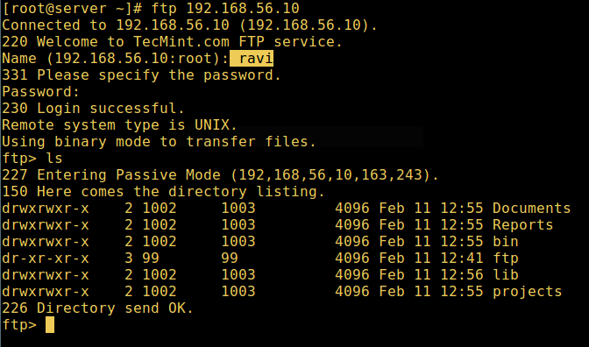  Step 5: Configure Different FTP User Home Directories  12. Open the vsftpd configuration file again and start by commenting the unsecure option below:  #allow_writeable_chroot=YES  Then create the alternative local root directory for the user (ravi) and remove write permissions to all users to this directory:  # mkdir /home/ravi/ftp  # chown nobody:nobody /home/ravi/ftp  # chmod a-w /home/ravi/ftp  13. create a directory under the local root where the user will store his/her files:  #mkdir /home/ravi/ftp/files  # chown ravi:ravi /home/ravi/ftp/files  # chmod 0700 /home/ravi/ftp/files/  Then add/modify the following options in the vsftpd config file with these values:  user_sub_token=$USER # inserts the username in the local root directory  local_root=/home/$USER/ftp # defines any users local root directory  Save the file and close it. Once again, let’s restart the service with the new settings:  # systemctl restart vsftpd  14. Now do a final test again and see that the users local root directory is the FTP directory we created in his home directory.  # ftp 192.168.56.10  Connected to 192.168.56.10 (192.168.56.10).  220 Welcome to TecMint.com FTP service.  Name (192.168.56.10:root) : ravi  331 Please specify the password.  Password:  230 Login successful.  Remote system type is UNIX.  Using binary mode to transfer files.  ftp> ls  output::  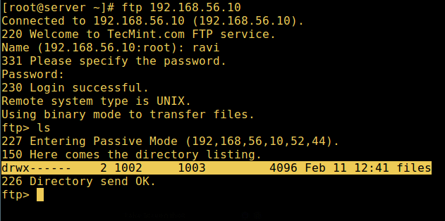
Conclusion | Thus, we can transfer files using ftp in linux.

Experiment No.10

Experiment Number | 10
Experiment Title | Perform remote login using telnet server
Resources / Apparatus Required | Hardware:  PC | Software:
Objectives  (Skill Set / Knowledge Tested / Imparted) | To perform remote login using telnet server
Theory/Diagrams/ER Diagrams/Code/Conclusion/  Real-Life Application/FAQ’s | 1.Install telnet use this command in terminal(Applications/Accessories/Terminal):  sudo apt-get install xinetd telnetd  2.Edit /etc/inetd.conf using your favourite file editor with root permission,add this line  telnet stream tcp nowait telnetd /usr/sbin/tcpd /usr/sbin/in.telnetd  3.Edit /etc/xinetd.conf,make its content look like following:  # Simple configuration file for xinetd  #  # Some defaults, and include /etc/xinetd.d/  defaults  {  # Please note that you need a log_type line to be able to use log_on_success  # and log_on_failure. The default is the following :  # log_type = SYSLOG daemon info  instances = 60  log_type = SYSLOG authpriv  log_on_success = HOST PID  log_on_failure = HOST  cps = 25 30  }  4.You can change telnet port number by edit /etc/services with this line:  telnet 23/tcp  5.If you’re not satisfied with default configuration.Edit etc/xinetd.d/telnet, add following:  # default: on  # description: The telnet server serves telnet sessions; it uses  # unencrypted username/password pairs for authentication.  service telnet  {  disable = no  flags = REUSE  socket_type = stream  wait = no  user = root  server = /usr/sbin/in.telnetd  log_on_failure += USERID  }  add these lines as you like  only_from = 192.168.120.0/24 #Only users in 192.168.120.0 can access to  only_from = .bob.com #allow access from bob.com  no_access = 192.168.120.{101,105} #not allow access from the two IP.  access_times = 8:00-9:00 20:00-21:00 #allow access in the two times  ......  6.Use this command to start telnet server:  sudo /etc/init.d/xinetd restart
Conclusion | This we can remotely login using telnet.

